TOOOPLE Login Credential
TOOOPLE CPANEL
http://tooople.com:2082/cpsess1762130320/frontend/paper_lantern/index.html?login=1&post_login=49458831711626
User name : tooop9ar
Password : tooople2016
0_7~?N9~HhFl
ZOOM User id and Password
user name : sistla.krishna@tooople.com
password : sistlak60

ZOOM id : 2914756034

celindavis@gmail.com
123456

Durai.raj@rydecs.com
Welcome_123

Rajeev@gmail.com
welcome123

jeyaseeliviolet@gmail.com
welcome123

celinStud1@gmail.com
lemon123

Customer Organisation
test.annauniversity@gmail.com
lemon123

gmail account

enquiry@tooople.com
tooople2016

test.saveethacollege@gmail.com - gmail a/c
lemon123
Customer Organisation --- Institution
test.saveethacollege@gmail.com --- tooople 647
welcome123
entering the institution details and then the representatives of that institution
- representative of the saveetha institution is Professor Gowri
testtooo.gowri@gmail.com
lemon123
testtooo.gowri@gmail.com 648
Greetings!
Thank you for your interest in registering with us.
User-Name:testtooo.gowri@gmail.com
Password:.123456.
Thank You,
Tooople Team
enquiries@tooople.com

Students
1.testtooo.uma@gmail.com – lemon123
2 . testtooo.banu@gmail.com -- lemon123

2nd Representatives of saveetha institution is brinda
Testtooo.brinda@gmail.com - lemon123 650
Greetings!
Thank you for your interest in registering with us.
User-Name:testtooo.brinda@gmail.com
Password:.123456.
Thank You,
Tooople Team
enquiries@tooople.com

New set of gmail id
lemon@123
inskarunya@gmail.com
irep.peterim@gmail.com
istud.pearlin@gmail.com
istud.karen@gmail.com
istud.sharonp@gmail.com

Individual student
Suganthi.stud@gmail.com
http://tooople.com/dev/index.php

25-07-2018
Vidhya.deviTOOO@gmail.com
lemon@123

User name:istud.pearlin@gmail.com
password:48D%DKUj
Students
- testtooo.kalavani@gmail.com -
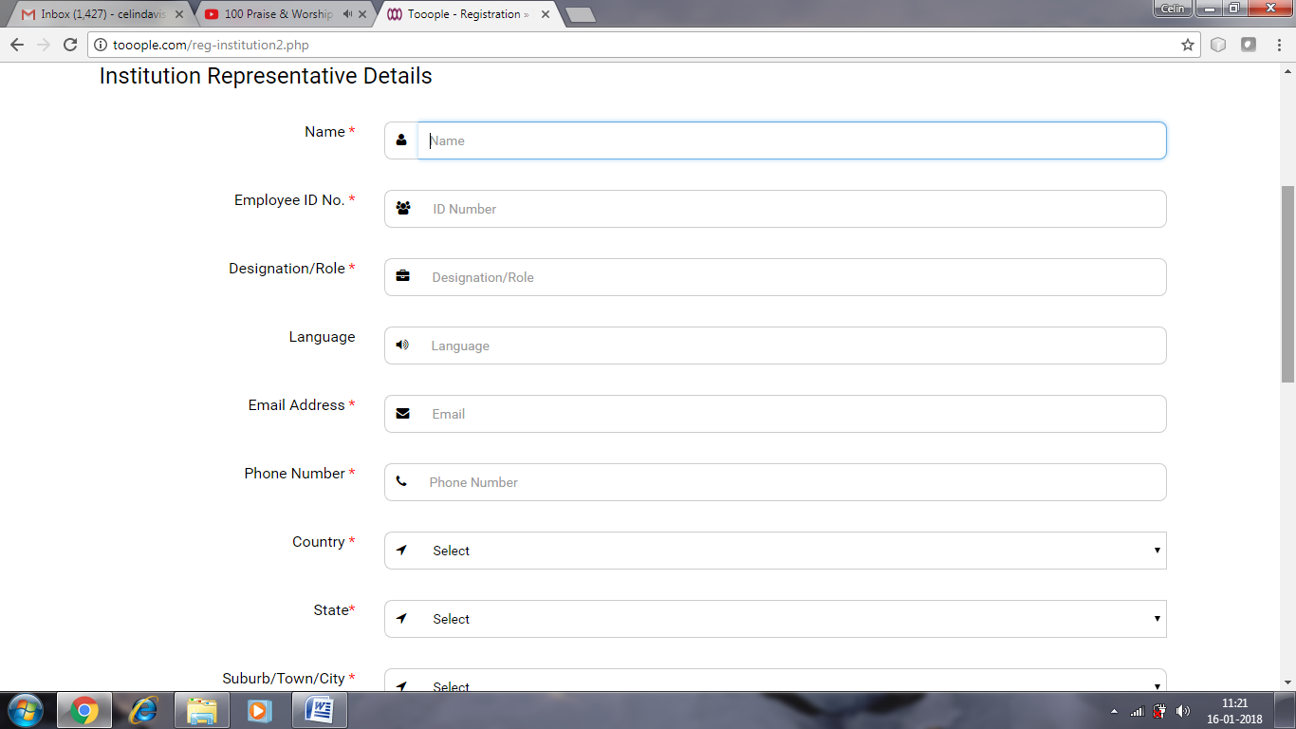

Institution name Institution mail Institution website phone address , country, city, state , pincode
Institution representative details
Name, employee id no, designation/role, language, email, phone no, country, state ,city , postal code

database tables
customer_organisation
co_representatives_details

Content Provider Organization:
Email ID : contentproviderorg@gmail.com
Password : 123456
Representative of Content Provider Organization :
Email ID : content.rep1@gmail.com /vinoddavis70@gmail.com
Password :
Content Provider :
Email ID : contentprovider123@gmail.com
Password : 123456

Mentor Organization:
Email ID : tooopletest1@gmail.com
Password : 123456
Representative of Mentor Organization :
Email ID : mentor.rep1@gmail.com
Password :
Mentor 1:
Email ID : mentorr01@gmail.com
Password : 123456
Mentor 2:
Email ID : chat2prakash93@gmail.com
Password : IOSsbMsT

Institution:
Email ID : tooopletest2@gmail.com
Password : 123456
Co-Ordinator :
Email ID : toooplecoordinator1@gmail.com
Password : 123456
Institution Student 1:
Name : Anish
Email ID : tooopletest3@gmail.com
Password : 123456
Institution Student 2:
Name : Chenna
Email ID : tooopletest4@gmail.com
Password : Fuk@2tt2
Institution Student 3:
Name : Ashok Kumar
Email ID : inforashok@gmail.com
Password : i6@0r$#9
Institution Student 4:
Name : Raghuram R
Email ID : inforashokkumar@gmail.com
Password : ##g8&iJG
Institution Student 5:
Name : Prakash A
Email ID : 0902prakash@gmail.com
Password : bsY%E%5G

Recruitment Organization :
Email ID : recuriting.org@gmail.com
Password : 123456

Internship Organization :
Email ID : intern.tooople@gmail.com
Password : 123456

Representative of Internship Organization :
Email ID : intern.tooople@gmail.com
Password :

